# A PERSONALIZED TRAVEL PLANNING AND TRACKING APP

PROJECT REPORT

*Submitted by*

|  |  |
| --- | --- |
| **TEAM MENBERS** | **NM ID** |
| **RAMKUMAR.P** | **E4EFB42A8C04097BDA9437CC0BBE2566** |
| **RAJESH.R** | **B6C0C7201A7EFB197BD414EBC3AC0BE8** |
| **LOGESWARAN.V** | **0824738CABEF658A113413712EA13671** |
| **ARUNKUMAR.N** | **494F2059A602104B5BC4B29AE8A83D21** |



## SRI SAI RANGANATHAN ENGINEERING COLLEGE COIMBATORE - 641109

**Project Description:**

A project built using the Android Compose UI toolkit. It demonstrates how to create a simple travel app using the Compose libraries. It also features a personalized feed of recommended accommodations based on the locations.

## DOWNLOAD ANDROID STUDIO :

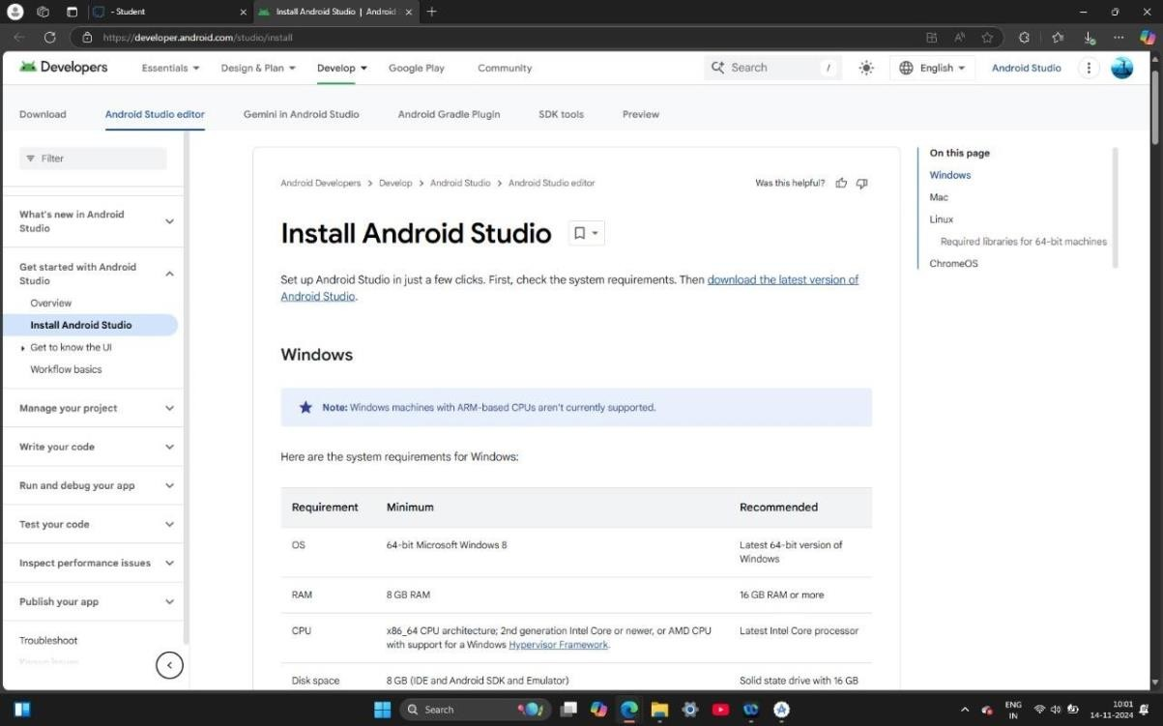

**INSTALLING ANDROID STUDIO** :

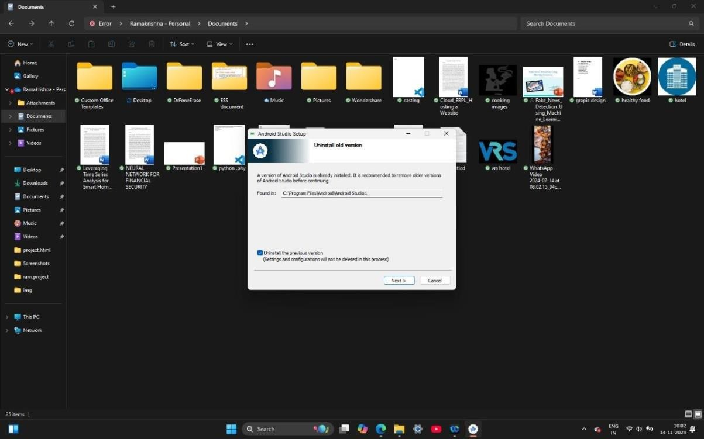

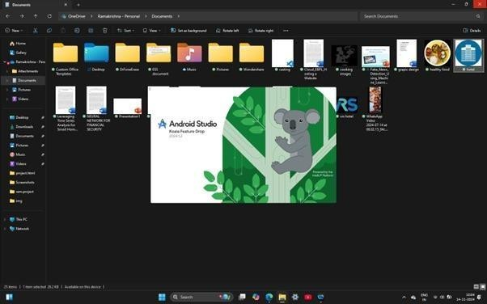

## CREATE NEW PROJECT :

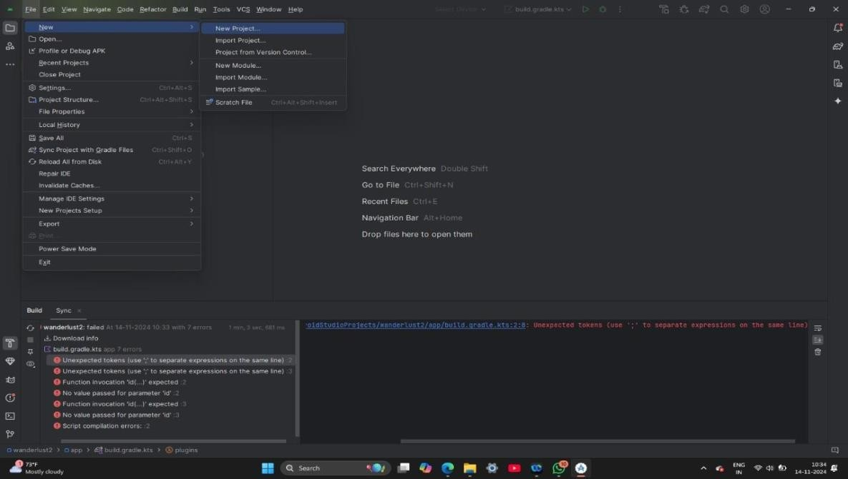

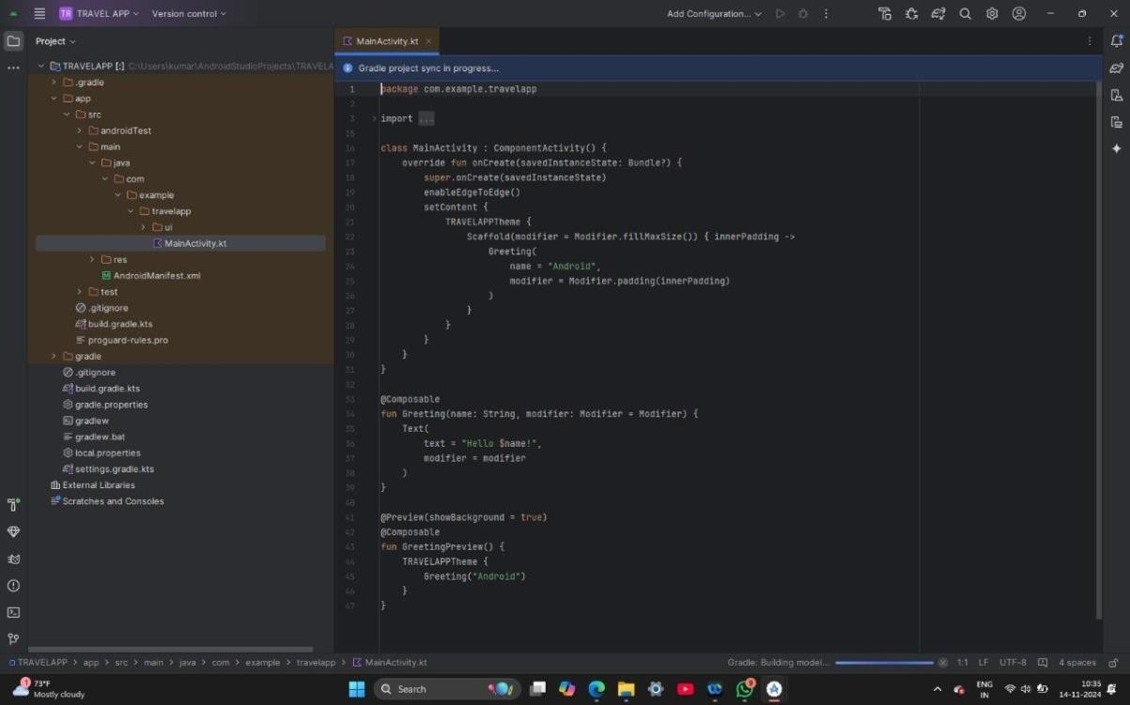

**STEP 1: GRADLE SCRIPTS**

plugins {

id 'com.android.application'

id 'org.jetbrains.kotlin.android'

}

android {

namespace 'com.example.travelapp' compileSdk 33

defaultConfig {

applicationId "com.example.travelapp" minSdk 21

targetSdk 33

versionCode 1

versionName "1.0"

testInstrumentationRunner "androidx.test.runner.AndroidJUnitRunner" vectorDrawables {

useSupportLibrary true

}

}

buildTypes { release {

minifyEnabled false

proguardFiles getDefaultProguardFile('proguard-android-optimize.txt'), 'proguard- rules.pro'

}

}

compileOptions {

**sourceCompatibility JavaVersion.*VERSION_1_8* targetCompatibility JavaVersion.*VERSION_1_8***

}

kotlinOptions { jvmTarget = '1.8'

}

buildFeatures { compose true

}

composeOptions { kotlinCompilerExtensionVersion '1.2.0'

}

packagingOptions { resources {

excludes += '/META-INF/{AL2.0,LGPL2.1}'

}

}

}

dependencies {

implementation 'androidx.core:core-ktx:1.7.0' implementation 'androidx.lifecycle:lifecycle-runtime-ktx:2.3.1' implementation 'androidx.activity:activity-compose:1.3.1'

implementation "androidx.compose.ui:ui:$compose_ui_version" implementation "androidx.compose.ui:ui-tooling-preview:$compose_ui_version" implementation 'androidx.compose.material:material:1.2.0'

implementation 'androidx.room:room-common:2.5.0' implementation 'androidx.room:room-ktx:2.5.0' testImplementation 'junit:junit:4.13.2' androidTestImplementation 'androidx.test.ext:junit:1.1.5'

androidTestImplementation 'androidx.test.espresso:espresso-core:3.5.1' androidTestImplementation "androidx.compose.ui:ui-test-junit4:$compose_ui_version" debugImplementation "androidx.compose.ui:ui-tooling:$compose_ui_version" debugImplementation "androidx.compose.ui:ui-test-manifest:$compose_ui_version"

}

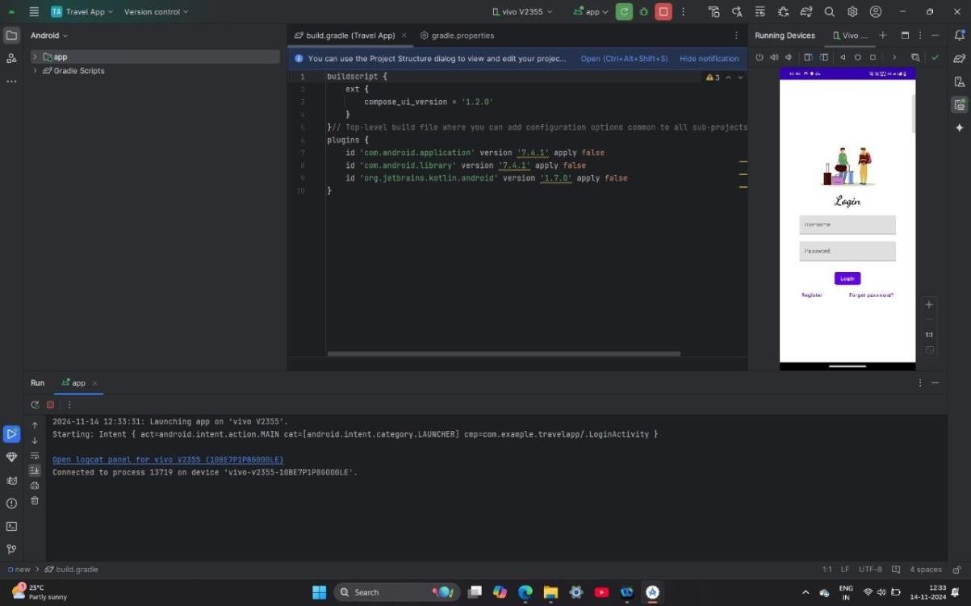

## STEP 2: ADD ROOM DEPENDENCIES

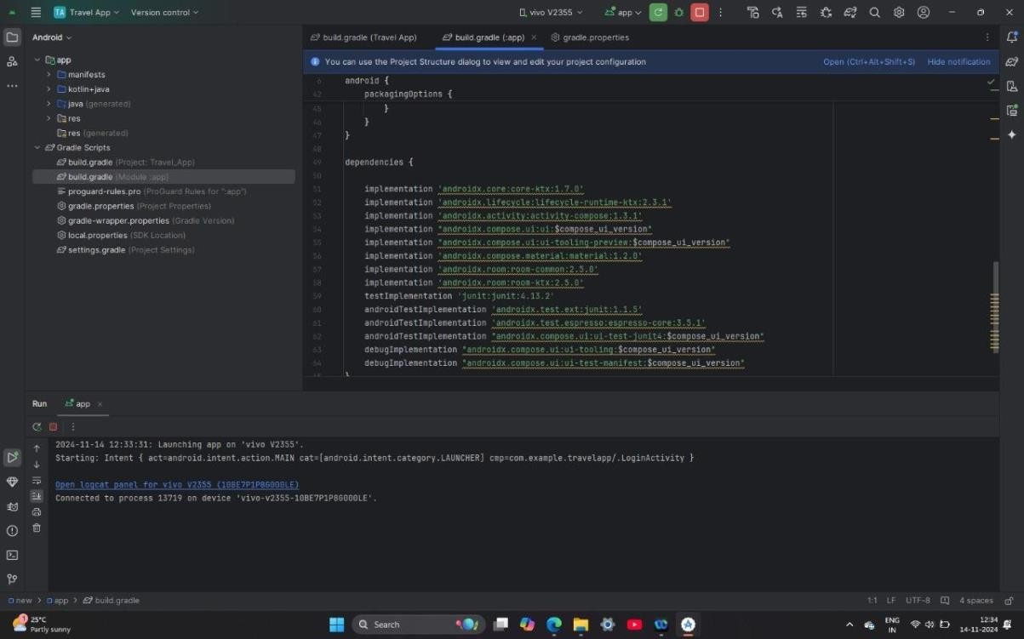

**CREATE DATABASE CLASSES:**

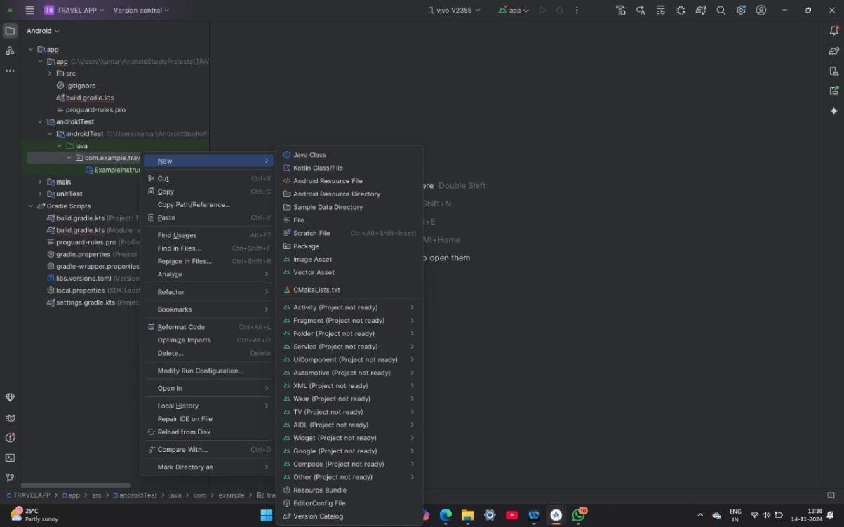

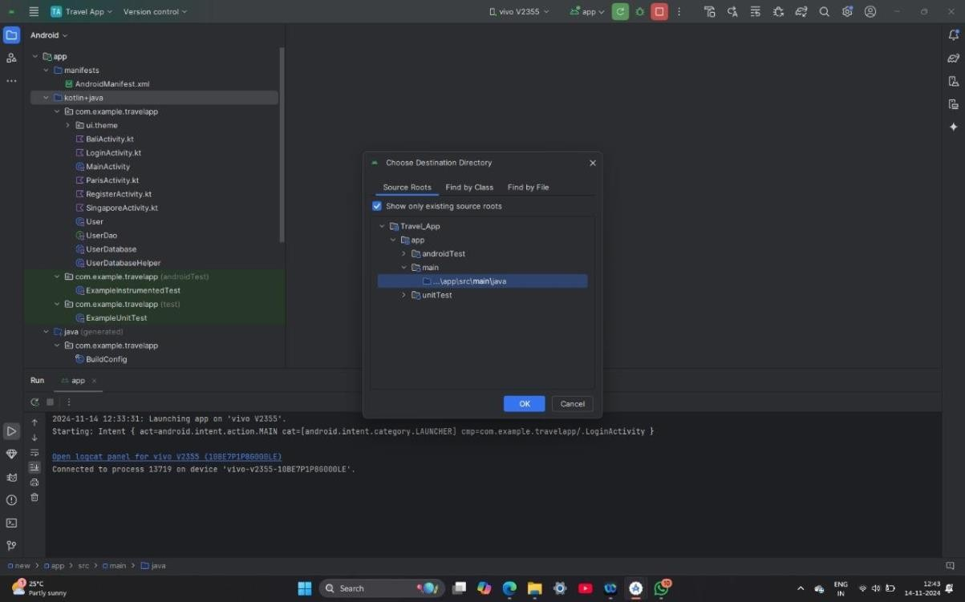

## STEP 1: CREATE USER CLASS

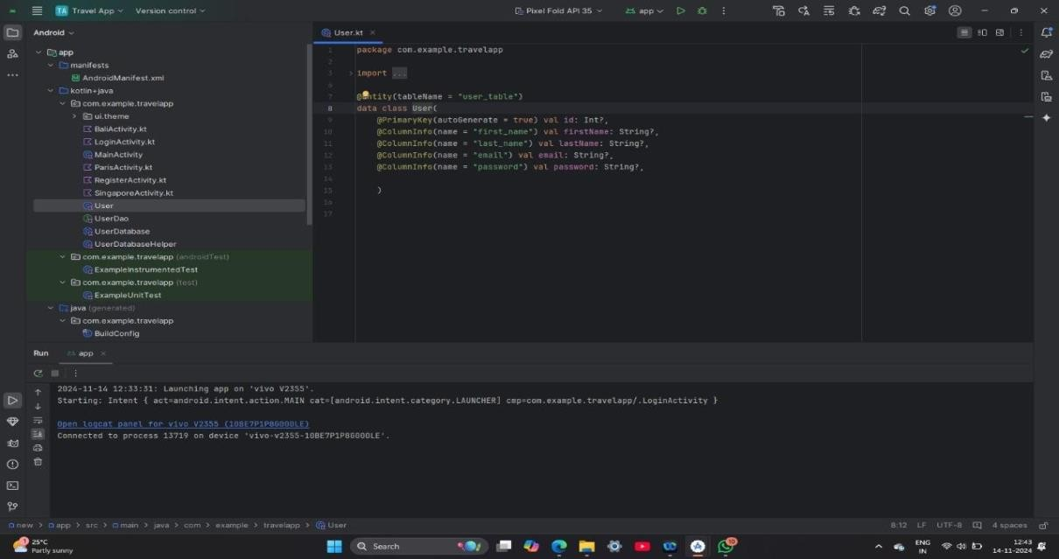

**STEP 2: CREATE USERDOA CLASS**

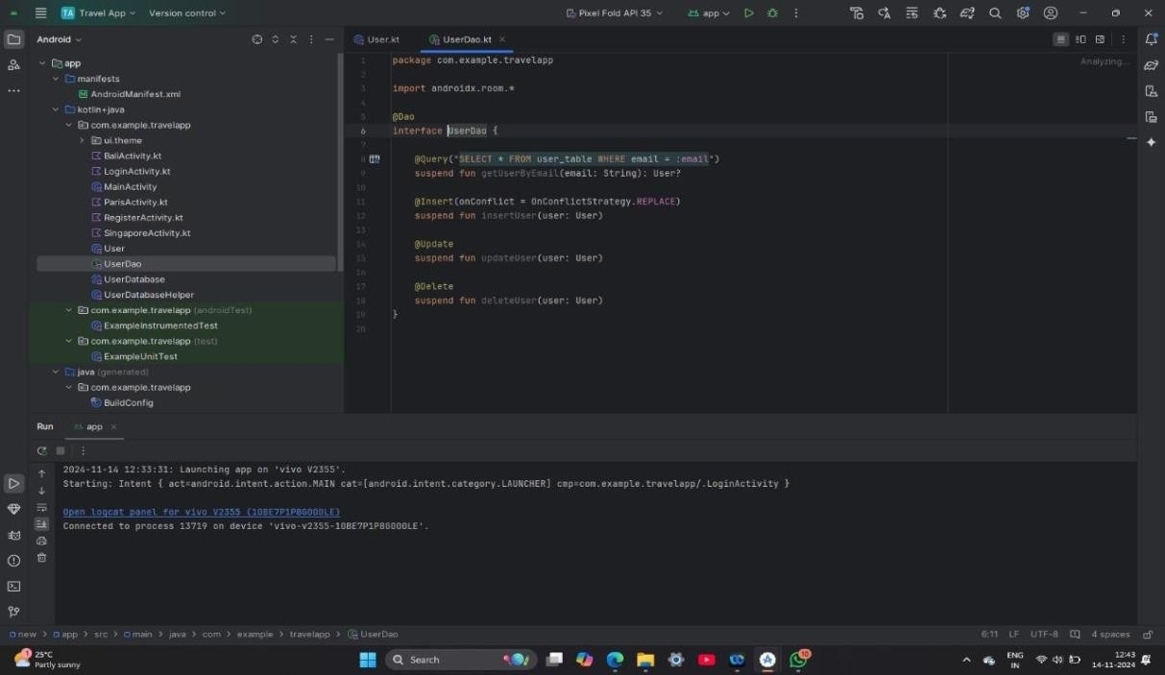

**STEP 3: CREATE A USERDATABASEHELPER**

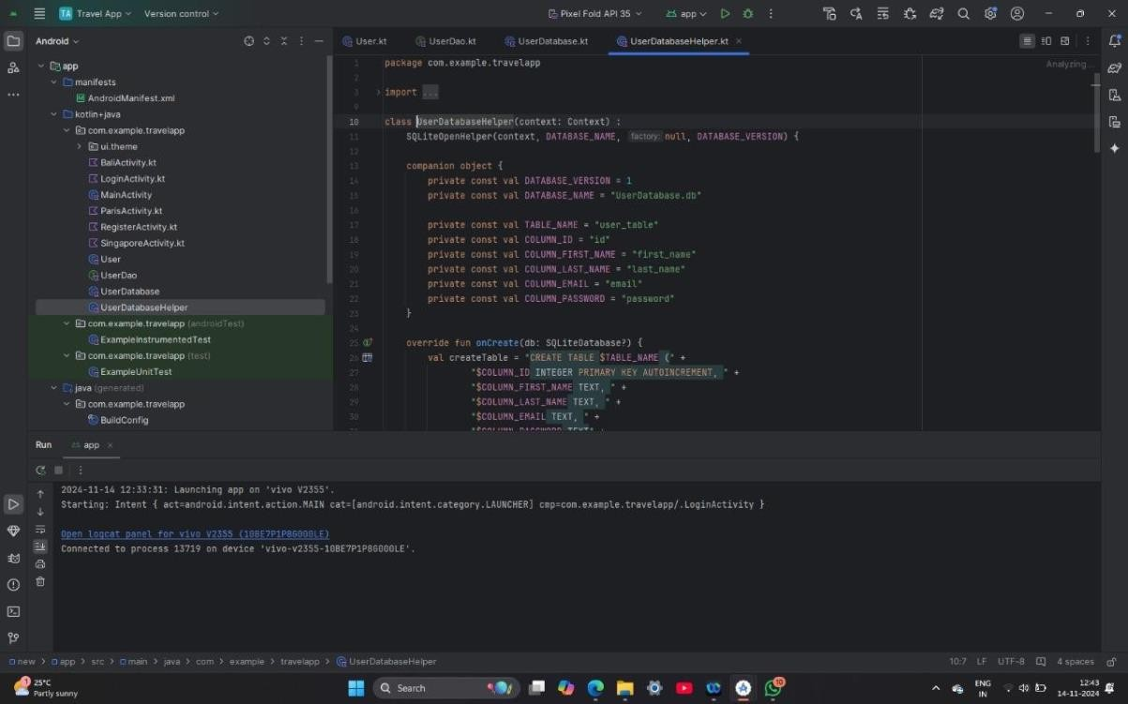

# Building application UI and connecting to database :

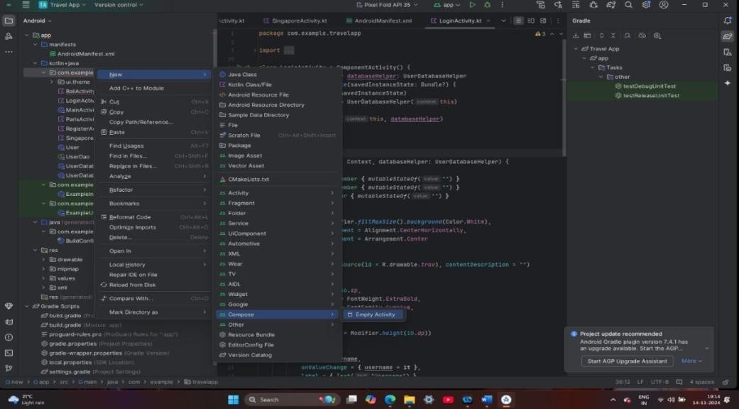

## CREATE LOGINACTIVITY :

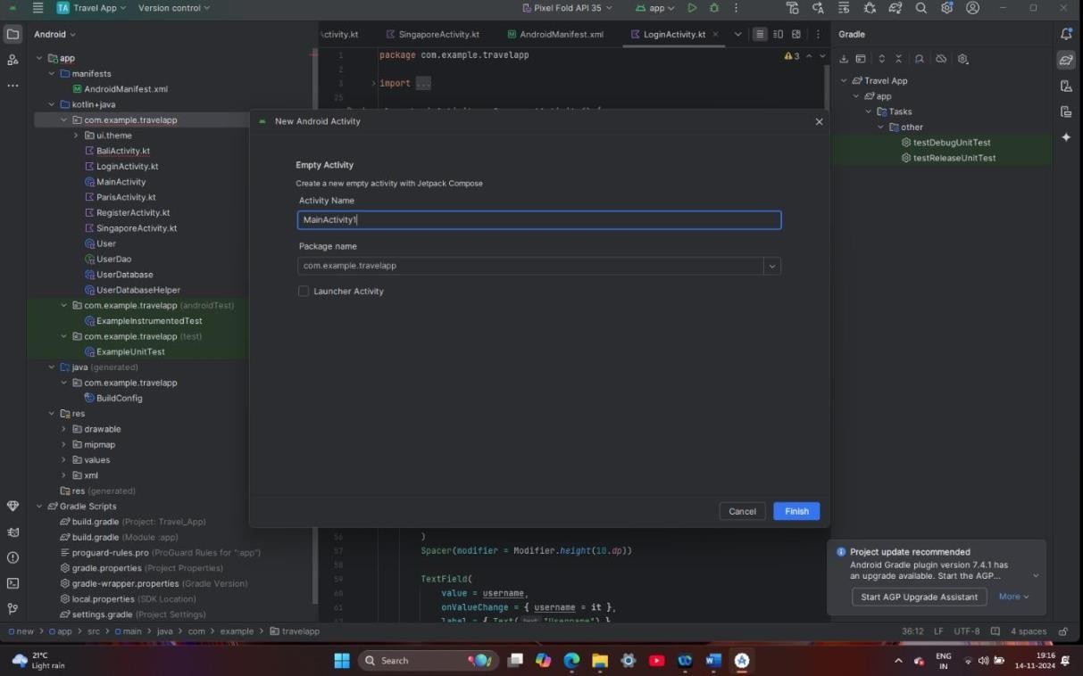

package com.example.travelapp

import android.content.Context import android.content.Intent import android.os.Bundle

import androidx.activity.ComponentActivity import androidx.activity.compose.setContent import androidx.compose.foundation.Image import androidx.compose.foundation.background import androidx.compose.foundation.layout.* import androidx.compose.material.*

import androidx.compose.runtime.* import androidx.compose.ui.Alignment import androidx.compose.ui.Modifier import androidx.compose.ui.graphics.Color

import androidx.compose.ui.layout.ContentScale import androidx.compose.ui.res.painterResource import androidx.compose.ui.text.font.FontFamily import androidx.compose.ui.text.font.FontWeight

import androidx.compose.ui.text.input.PasswordVisualTransformation import androidx.compose.ui.tooling.preview.Preview

import androidx.compose.ui.unit.dp

import androidx.compose.ui.unit.sp

import androidx.core.content.ContextCompat

class LoginActivity : ComponentActivity() {

private lateinit var databaseHelper: UserDatabaseHelper override fun onCreate(savedInstanceState: Bundle?) {

super.onCreate(savedInstanceState) databaseHelper = UserDatabaseHelper(this) *setContent* {

LoginScreen(this, databaseHelper)

}

}

}

@Composable

fun LoginScreen(context: Context, databaseHelper: UserDatabaseHelper) {

**var username by remember { *mutableStateOf*("") } var password by remember { *mutableStateOf*("") } var error by remember { *mutableStateOf*("") }**

Column(

modifier = Modifier.*fillMaxSize*().*background*(Color.White), horizontalAlignment = Alignment.CenterHorizontally, verticalArrangement = Arrangement.Center

) {

Image(painterResource(id = R.drawable.*trav*), contentDescription = "")

Text(

fontSize = 36.*sp*,

fontWeight = FontWeight.ExtraBold, fontFamily = FontFamily.Cursive, text = "Login"

)

Spacer(modifier = Modifier.*height*(10.*dp*))

TextField(

value = username,

onValueChange = { username = it }, label = { Text("Username") }, modifier = Modifier.*padding*(10.*dp*)

**.*width*(280.*dp*)**

)

TextField(

value = password,

onValueChange = { password = it }, label = { Text("Password") },

visualTransformation = PasswordVisualTransformation(), modifier = Modifier.*padding*(10.*dp*)

**.*width*(280.*dp*)**

)

**if (error.*isNotEmpty*()) { Text(**

text = error,

color = MaterialTheme.colors.error,

modifier = Modifier.*padding*(vertical = 16.*dp*)

)

}

Button( onClick = {

**if (username.*isNotEmpty*() && password.*isNotEmpty*()) {**

val user = databaseHelper.getUserByUsername(username) if (user != null && user.password == password) {

error = "Successfully log in" context.startActivity(

Intent(

context, MainActivity::class.*java*

)

)

//onLoginSuccess()

}

else {

error = "Invalid username or password"

}

} else {

error = "Please fill all fields"

}

},

**modifier = Modifier.*padding*(top = 16.*dp*)**

) {

Text(text = "Login")

}

Row {

TextButton(onClick = {context.startActivity( Intent(

context, RegisterActivity::class.*java*

)

)}

)

{ Text(text = "Register") } TextButton(onClick = {

})

{

Spacer(modifier = Modifier.*width*(60.*dp*)) Text(text = "Forget password?")

}

}

}

}

private fun startMainPage(context: Context) {

val intent = Intent(context, MainActivity::class.*java*) ContextCompat.startActivity(context, intent, null)

}

## CREATING REGISTER ACTIVITY :

package com.example.travelapp

import android.content.Context import android.content.Intent import android.os.Bundle

import androidx.activity.ComponentActivity import androidx.activity.compose.setContent import androidx.compose.foundation.Image import androidx.compose.foundation.background import androidx.compose.foundation.layout.* import androidx.compose.material.*

import androidx.compose.runtime.* import androidx.compose.ui.Alignment import androidx.compose.ui.Modifier import androidx.compose.ui.graphics.Color

import androidx.compose.ui.layout.ContentScale import androidx.compose.ui.res.painterResource import androidx.compose.ui.text.font.FontFamily import androidx.compose.ui.text.font.FontWeight

import androidx.compose.ui.text.input.PasswordVisualTransformation

import androidx.compose.ui.tooling.preview.Preview import androidx.compose.ui.unit.dp

import androidx.compose.ui.unit.sp

import androidx.core.content.ContextCompat

class RegisterActivity : ComponentActivity() {

private lateinit var databaseHelper: UserDatabaseHelper override fun onCreate(savedInstanceState: Bundle?) {

super.onCreate(savedInstanceState) databaseHelper = UserDatabaseHelper(this) *setContent* {

RegistrationScreen(this, databaseHelper)

}

}

}

@Composable

fun RegistrationScreen(context: Context, databaseHelper: UserDatabaseHelper) {

**var username by remember { *mutableStateOf*("") } var password by remember { *mutableStateOf*("") } var email by remember { *mutableStateOf*("") }**

**var error by remember { *mutableStateOf*("") }**

Column(

modifier = Modifier.*fillMaxSize*().*background*(Color.White), horizontalAlignment = Alignment.CenterHorizontally, verticalArrangement = Arrangement.Center

) {

Image(painterResource(id = R.drawable.*tra*), contentDescription = "")

Text(

fontSize = 36.*sp*,

fontWeight = FontWeight.ExtraBold, fontFamily = FontFamily.Cursive, text = "Register"

)

Spacer(modifier = Modifier.*height*(10.*dp*)) TextField(

value = username,

onValueChange = { username = it }, label = { Text("Username") },

modifier = Modifier

**.*padding*(10.*dp*)**

**.*width*(280.*dp*)**

)

TextField(

value = email,

onValueChange = { email = it }, label = { Text("Email") }, modifier = Modifier

**.*padding*(10.*dp*)**

**.*width*(280.*dp*)**

)

TextField(

value = password,

onValueChange = { password = it }, label = { Text("Password") },

visualTransformation = PasswordVisualTransformation(), modifier = Modifier

**.*padding*(10.*dp*)**

**.*width*(280.*dp*)**

)

**if (error.*isNotEmpty*()) { Text(**

text = error,

color = MaterialTheme.colors.error,

modifier = Modifier.*padding*(vertical = 16.*dp*)

)

}

Button( onClick = {

**if (username.*isNotEmpty*() && password.*isNotEmpty*() && email.*isNotEmpty*()) { val user = User(**

id = null,

firstName = username, lastName = null,

email = email, password = password

)

databaseHelper.insertUser(user) error = "User registered successfully"

// Start LoginActivity using the current context context.startActivity(

Intent(

context, LoginActivity::class.*java*

)

)

} else {

error = "Please fill all fields"

}

},

**modifier = Modifier.*padding*(top = 16.*dp*)**

) {

Text(text = "Register")

}

Spacer(modifier = Modifier.*width*(10.*dp*)) Spacer(modifier = Modifier.*height*(10.*dp*))

Row() {

Text(

modifier = Modifier.*padding*(top = 14.*dp*), text = "Have an account?"

)

TextButton(onClick = { context.startActivity(

Intent(

context, LoginActivity::class.*java*

)

)

})

{

Spacer(modifier = Modifier.*width*(10.*dp*)) Text(text = "Log in")

}

}

}

}

private fun startLoginActivity(context: Context) {

val intent = Intent(context, LoginActivity::class.*java*)

ContextCompat.startActivity(context, intent, null)

}

## CREATE MAIN ACTIVITY :

package com.example.travelapp

import android.content.Context import android.content.Intent import android.os.Bundle

import androidx.activity.ComponentActivity import androidx.activity.compose.setContent import androidx.compose.foundation.Image import androidx.compose.foundation.clickable import androidx.compose.foundation.layout.*

import androidx.compose.foundation.rememberScrollState import androidx.compose.foundation.verticalScroll

import androidx.compose.material.Card import androidx.compose.material.Text

import androidx.compose.runtime.Composable import androidx.compose.ui.Alignment

import androidx.compose.ui.Modifier import androidx.compose.ui.draw.scale import androidx.compose.ui.graphics.Color

import androidx.compose.ui.res.painterResource import androidx.compose.ui.res.stringResource import androidx.compose.ui.text.font.FontFamily import androidx.compose.ui.text.font.FontWeight import androidx.compose.ui.text.style.TextAlign import androidx.compose.ui.unit.dp

import androidx.compose.ui.unit.sp

class MainActivity : ComponentActivity() {

override fun onCreate(savedInstanceState: Bundle?) { super.onCreate(savedInstanceState)

***setContent* { TravelApp(this)**

}

}

@Composable

fun TravelApp(context: Context) { Column(

modifier = Modifier

**.*padding*(20.*dp*)**

**.*verticalScroll*(rememberScrollState())**

) {

Text(

fontSize = 40.*sp*,

color = *Color*(android.graphics.Color.rgb(120, 40, 251)), fontFamily = FontFamily.Cursive,

text = "Wanderlust Travel"

)

Spacer(modifier = Modifier.*height*(20.*dp*))

// 01

Card(

modifier = Modifier

**.*fillMaxWidth*()**

**.*height*(250.*dp*)**

**.*clickable* { context.startActivity(**

Intent(context, BaliActivity::class.java)

)

},

elevation = 8.*dp*

)

{

Column(

horizontalAlignment = Alignment.CenterHorizontally

) {

Image(

painterResource(id = R.drawable.*bali*), contentDescription = "", modifier = Modifier

**.*height*(150.*dp*)**

.*scale*(scaleX = 1.2F, scaleY = 1F)

)

Text(

text = stringResource(id = R.string.*place_1*), fontSize = 18.*sp*

)

Text(

text = stringResource(id = R.string.*description*), fontWeight = FontWeight.Light,

fontSize = 16.*sp*,

textAlign = TextAlign.Center,

)

Text(

text = stringResource(id = R.string.*plan*), color = Color.Gray, fontSize = 16.*sp*

)

}

}

Spacer(modifier = Modifier.*height*(20.*dp*))

//02

Card(

modifier = Modifier

**.*fillMaxWidth*()**

**.*height*(250.*dp*)**

**.*clickable* { context.startActivity(**

Intent(context, ParisActivity::class.*java*)

)

},

elevation = 8.*dp*

)

{

Column(

horizontalAlignment = Alignment.CenterHorizontally

) {

Image(

painterResource(id = R.drawable.*paris*), contentDescription = "", modifier = Modifier

**.*height*(150.*dp*)**

.*scale*(scaleX = 1.2F, scaleY = 1F)

)

Text(

text = stringResource(id = R.string.*place_2*), fontSize = 18.*sp*

)

Text(

text = stringResource(id = R.string.*description*), fontWeight = FontWeight.Light,

fontSize = 16.*sp*,

textAlign = TextAlign.Center,

)

Text(

text = stringResource(id = R.string.*plan*), color = Color.Gray, fontSize = 16.*sp*

)

}

}

Spacer(modifier = Modifier.*height*(20.*dp*))

//03

Card(

modifier = Modifier

**.*fillMaxWidth*()**

**.*height*(250.*dp*)**

**.*clickable* { context.startActivity(**

Intent(context, SingaporeActivity::class.*java*)

)

},

elevation = 8.*dp*

)

{

Column(

horizontalAlignment = Alignment.CenterHorizontally

) {

Image(

painterResource(id = R.drawable.*singapore*), contentDescription = "", modifier = Modifier

**.*height*(150.*dp*)**

.*scale*(scaleX = 1.2F, scaleY = 1F)

)

Text(

text = stringResource(id = R.string.*place_3*), fontSize = 18.*sp*

)

Text(

text = stringResource(id = R.string.*description*), fontWeight = FontWeight.Light,

fontSize = 16.*sp*,

textAlign = TextAlign.Center,

)

Text(

text = stringResource(id = R.string.*plan*), color = Color.Gray, fontSize = 16.*sp*

)

}

}

Spacer(modifier = Modifier.*height*(20.*dp*))

}

}

}

## CREATE BALI ACTIVITY :

.2package com.example.travelapp

import android.os.Bundle

import androidx.activity.ComponentActivity import androidx.activity.compose.setContent import androidx.compose.foundation.Image import androidx.compose.foundation.background import androidx.compose.foundation.layout.*

import androidx.compose.foundation.rememberScrollState import androidx.compose.foundation.verticalScroll

import androidx.compose.material.MaterialTheme import androidx.compose.material.Surface

import androidx.compose.material.Text

import androidx.compose.runtime.Composable import androidx.compose.ui.Modifier

import androidx.compose.ui.draw.scale import androidx.compose.ui.graphics.Color

import androidx.compose.ui.res.painterResource

import androidx.compose.ui.res.stringResource import androidx.compose.ui.text.font.FontFamily import androidx.compose.ui.tooling.preview.Preview import androidx.compose.ui.unit.dp

import androidx.compose.ui.unit.sp

import com.example.travelapp.ui.theme.TravelAppTheme

class BaliActivity : ComponentActivity() {

override fun onCreate(savedInstanceState: Bundle?) { super.onCreate(savedInstanceState)

***setContent* { TravelAppTheme {**

// A surface container using the 'background' color from the theme Surface(

**modifier = Modifier.*fillMaxSize*(),**

color = MaterialTheme.colors.background

) {

PlaceOne()

}

}

}

}

}

@Composable fun PlaceOne() {

Column(modifier = Modifier.*background*(color = Color.White)

**.*padding*(20.*dp*)**

**.*verticalScroll*(rememberScrollState())**

) {

Text(

fontSize = 40.*sp*,

color = *Color*(android.graphics.Color.rgb(120, 40, 251)), fontFamily = FontFamily.Cursive,

text = stringResource(id = R.string.place_1),

)

Image(

painterResource(id = R.drawable.bali), contentDescription = "", modifier = Modifier

**.*padding*(16.*dp*)**

**.*fillMaxWidth*()**

**.*height*(200.*dp*)**

.*scale*(scaleX = 1F, scaleY = 1F)

)

Text(

color=Color.Black,

text = "Day 1: Arrival and Relaxation\n" +

"Arrive in Bali and check into your hotel or accommodation.\n" + "Spend the day relaxing and getting acclimated to the island.\n" +

"If you have time, explore the nearby area or head to the beach.\n" + "\n" +

"Day 2: Ubud Tour\n" +

Site.\n" +

+

+

"Start your day early and head to Ubud, a cultural and artistic hub in Bali.\n" + "Visit the Monkey Forest and the Ubud Palace.\n" +

"Take a tour of the Tegalalang Rice Terrace, a beautiful UNESCO World Heritage

"End your day with a traditional Balinese dance performance.\n" + "\n" +

"Day 3: Temple Hopping\n" +

"Visit some of Bali's most famous temples, such as Tanah Lot and Uluwatu.\n" "Take in the stunning views of the ocean and cliffs.\n" +

"Enjoy a sunset dinner at one of the many restaurants near the temples.\n" +

"\n" +

"Day 4: Waterfalls and Beaches\n" +

"Take a day trip to Bali's beautiful waterfalls, such as Tegenungan or Gitgit.\n" "Spend the afternoon at one of Bali's world-renowned beaches, like Seminyak

or Nusa Dua.\n" +

"\n" +

"Day 5: Island Hopping\n" +

"Take a day trip to one of Bali's neighboring islands, such as Nusa Lembongan or Gili Islands.\n" +

"Snorkel or scuba dive in the clear waters and relax on the beach.\n" + "\n" +

"Day 6: Cultural Activities\n" +

"Visit a traditional Balinese village and learn about the island.\n" + "\n" +

"Day 7: Departure\n" +

"Explore the surrounding area and take in the stunning sunset views.\n" + "Have dinner at a local restaurant before returning to your accommodation."

)

}

}

## CREATE PARIS ACTIVITY :

package com.example.travelapp

import android.os.Bundle

import androidx.activity.ComponentActivity import androidx.activity.compose.setContent import androidx.compose.foundation.Image import androidx.compose.foundation.background import androidx.compose.foundation.layout.*

import androidx.compose.foundation.rememberScrollState import androidx.compose.foundation.verticalScroll

import androidx.compose.material.MaterialTheme import androidx.compose.material.Surface

import androidx.compose.material.Text

import androidx.compose.runtime.Composable import androidx.compose.ui.Modifier

import androidx.compose.ui.draw.scale import androidx.compose.ui.graphics.Color

import androidx.compose.ui.res.painterResource import androidx.compose.ui.res.stringResource import androidx.compose.ui.text.font.FontFamily import androidx.compose.ui.tooling.preview.Preview import androidx.compose.ui.unit.dp

import androidx.compose.ui.unit.sp

import com.example.travelapp.ui.theme.TravelAppTheme

class ParisActivity : ComponentActivity() {

override fun onCreate(savedInstanceState: Bundle?) { super.onCreate(savedInstanceState)

setContent { TravelAppTheme {

// A surface container using the 'background' color from the theme Surface(

**modifier = Modifier.*fillMaxSize*(),**

color = MatCreating erialTheme.colors.background

) {

Greeting()

}

}

}

}

}

@Composable fun Greeting() {

Column(

modifier = Modifier.*background*(color = Color.White)

**.*padding*(20.*dp*)**

**.*verticalScroll*(rememberScrollState())**

) {

Text(

fontSize = 40.*sp*,

color = *Color*(android.graphics.Color.rgb(120, 40, 251)), fontFamily = FontFamily.Cursive,

text = stringResource(id = R.string.*place_2*),

)

Image(

painterResource(id = R.drawable.*paris*), contentDescription = "", modifier = Modifier

**.*padding*(16.*dp*)**

**.*fillMaxWidth*()**

**.*height*(200.*dp*)**

.*scale*(scaleX = 1.2F, scaleY = 1F)

)

Text(

color=Color.Black,

text = "Day 1: Arrival and Introduction\n" +

"Check into your accommodation and freshen up\n" +

"Take a stroll around the neighborhood to get acquainted\n" +

"Visit the Eiffel Tower, preferably in the evening when it is lit up\n" + "Have a relaxing dinner at a nearby restaurant\n" +

"\n" +

"Day 2: Art and History\n" +

"Visit the Louvre Museum to see some of the world's most famous art pieces\n" +

"Stroll through the Tuileries Garden and the Place de la Concorde\n" + "Visit the Orsay Museum, which houses a large collection of impressionist

art\n" +

"Have dinner at a local French restaurant\n" +

"\n" +

"Day 3: French Culture and Food\n" +

"Visit the Montmartre neighborhood to see the famous Basilique du Sacré-

Cœur and Place du Tertre\n" +

"Explore the historic neighborhood of Le Marais\n" + "Try some delicious French pastries at a local bakery\n" +

"Have dinner at a brasserie to taste some classic French cuisine\n" + "\n" +

"Day 4: Architecture and Gardens\n" +

"Visit the Palace of Versailles, a UNESCO World Heritage site, and explore its beautiful gardens\n" +

"Walk along the Champs-Elysées and stop at the Arc de Triomphe\n" +

"Visit the Sainte-Chapelle, a beautiful Gothic chapel with stunning stained-glass windows\n" +

"Have dinner at a local restaurant in the 7th arrondissement\n" +

"\n" +

"Day 5: Shopping and Sightseeing\n" +

"Visit the Notre-Dame Cathedral and climb up to the top for a stunning view of the city\n" +

"Explore the Latin Quarter and visit the Panthéon\n" +

"Go shopping at the famous Galeries Lafayette or Printemps department stores\n" +

"Have dinner at a local bistro\n" + "\n" +

"Day 6: Parisian Parks and Museums\n" +

"Visit the Musée Rodin and explore its beautiful gardens\n" +

"Stroll through the Luxembourg Gardens and visit the Luxembourg Palace\n" + "Visit the Centre Pompidou, a modern art museum in the Marais

neighborhood\n" +

"Have dinner at a local restaurant in the Latin Quarter\n" + "\n" +

"Day 7: River Cruise and Farewell\n" +

"Take a boat cruise along the Seine River to see the city from a different perspective\n" +

"Visit the Musée de l'Orangerie, which houses Monet's famous water lilies

paintings\n" +

"Have a farewell dinner at a Michelin-starred restaurant"

)

}

}

## CREATE SINGAPORE ACTIVITY :

package com.example.travelapp

import android.os.Bundle

import androidx.activity.ComponentActivity import androidx.activity.compose.setContent import androidx.compose.foundation.Image import androidx.compose.foundation.background import androidx.compose.foundation.layout.*

import androidx.compose.foundation.rememberScrollState import androidx.compose.foundation.verticalScroll

import androidx.compose.material.MaterialTheme import androidx.compose.material.Surface

import androidx.compose.material.Text

import androidx.compose.runtime.Composable import androidx.compose.ui.Modifier

import androidx.compose.ui.draw.scale import androidx.compose.ui.graphics.Color

import androidx.compose.ui.res.painterResource import androidx.compose.ui.res.stringResource import androidx.compose.ui.text.font.FontFamily import androidx.compose.ui.tooling.preview.Preview import androidx.compose.ui.unit.dp

import androidx.compose.ui.unit.sp

import com.example.travelapp.ui.theme.TravelAppTheme

class SingaporeActivity : ComponentActivity() { override fun onCreate(savedInstanceState: Bundle?) {

super.onCreate(savedInstanceState)

***setContent* { TravelAppTheme {**

// A surface container using the 'background' color from the theme Surface(

**modifier = Modifier.*fillMaxSize*(),**

color = MaterialTheme.colors.background

) {

Greeting2()

}

}

}

}

}

@Composable fun Greeting2() {

Column(

modifier = Modifier.*background*(color = Color.White)

**.*padding*(20.*dp*)**

**.*verticalScroll*(rememberScrollState())**

) {

Text(

fontSize = 40.*sp*,

color = *Color*(android.graphics.Color.rgb(120, 40, 251)), fontFamily = FontFamily.Cursive,

text = stringResource(id = R.string.*place_3*),

)

Image(

painterResource(id = R.drawable.*singapore*), contentDescription = "", modifier = Modifier

**.*padding*(16.*dp*)**

**.*fillMaxWidth*()**

**.*height*(200.*dp*)**

.*scale*(scaleX = 1.2F, scaleY = 1F)

)

Text(

color = Color.Black, text = "Day 1:\n" +

"Morning: Visit Gardens by the Bay and marvel at the Supertree Grove and the Flower Dome and Cloud Forest conservatories.\n" +

"Afternoon: Explore the Marina Bay Sands complex, which includes a casino, luxury shopping mall, and observation deck with a stunning view of the city.\n" +

"\n" +

"Day 2:\n" +

"Morning: Explore the historic district of Chinatown, including the Buddha Tooth Relic Temple and Museum and the Sri Mariamman Temple.\n" +

"Afternoon: Visit the nearby Clarke Quay for lunch and to explore its waterfront restaurants, bars, and shops.\n" +

"\n" +

"Day 3:\n" +

"Morning: Take a tour of the UNESCO-listed Botanic Gardens, one of the world's most famous and significant tropical gardens.\n" +

"Afternoon: Head over to the National Museum of Singapore, which houses a vast collection of historical and cultural artifacts.\n" +

"\n" +

"Day 4:\n" +

"Morning: Visit the Singapore Zoo and admire the wildlife, including orangutans, tigers, and elephants.\n" +

"Afternoon: Head over to Sentosa Island and relax at one of its many beaches or try some of the many attractions such as Universal Studios Singapore or Adventure Cove Waterpark.\n" +

"\n" +

"Day 5:\n" +

"Morning: Go on a nature walk at MacRitchie Reservoir, which offers hiking trails and stunning views of the city skyline.\n" +

"Afternoon: Visit Little India, a vibrant and colorful neighborhood, and explore the shops, temples, and food stalls.\n" +

"\n" +

"Day 6:\n" +

"Morning: Explore the trendy neighborhood of Tiong Bahru, known for its hip cafes and boutiques, as well as its Art Deco architecture.\n" +

"Afternoon: Visit the National Gallery Singapore, which houses the largest public collection of modern art in Singapore and Southeast Asia.\n" +

"\n" +

"Day 7:\n" +

"Morning: Take a day trip to the nearby island of Pulau Ubin, where you can

rent a "

)

}

}

## MODIFY ANDROID MANIFEST :

<?xml version="1.0" encoding="utf-8"?>

<manifest xmlns:android="<http://schemas.android.com/apk/res/android>" xmlns:tools="[http://schemas.android.com/tools">](http://schemas.android.com/tools)

<application android:allowBackup="true"

android:dataExtractionRules="@xml/data_extraction_rules" android:fullBackupContent="@xml/backup_rules" android:icon="@mipmap/ic_launcher" android:label="@string/app_name" android:supportsRtl="true" android:theme="@style/Theme.TravelApp" tools:targetApi="31">

<activity android:name=".RegisterActivity" android:exported="false" android:label="RegisterActivity"

android:theme="@style/Theme.TravelApp" />

<activity android:name=".SingaporeActivity" android:exported="false"

android:label="@string/title_activity_singapore" android:theme="@style/Theme.TravelApp" />

<activity android:name=".ParisActivity" android:exported="false"

android:label="@string/title_activity_paris" android:theme="@style/Theme.TravelApp" />

<activity android:name=".BaliActivity" android:exported="false"

android:label="@string/title_activity_bali" android:theme="@style/Theme.TravelApp" />

<activity android:name=".MainActivity" android:exported="true" android:label="@string/app_name"

android:theme="@style/Theme.TravelApp"/>

<activity android:name=".LoginActivity" android:exported="true" android:label="@string/app_name"

android:theme="@style/Theme.TravelApp">

<intent-filter>

<action android:name="android.intent.action.MAIN" />

<category android:name="android.intent.category.LAUNCHER" />

</intent-filter>

</activity>

</application>

</manifest>

RUNNING APPLICATION :

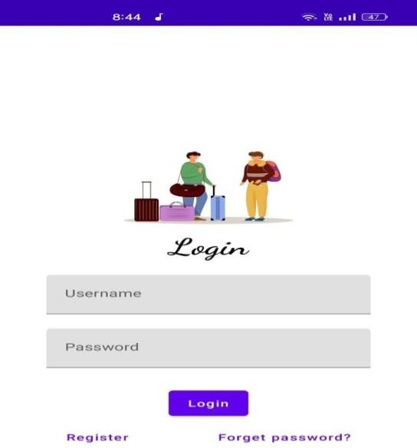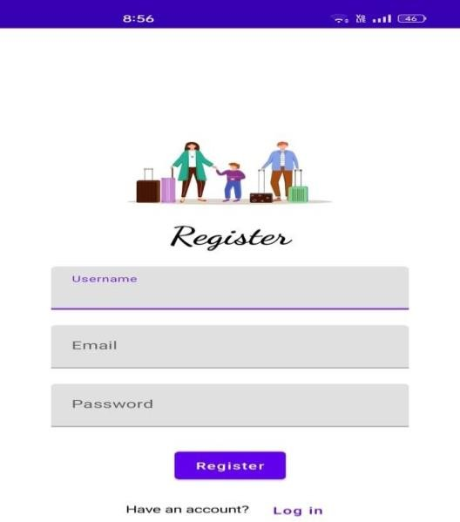

FIRST PAGE REGISTER PAGE

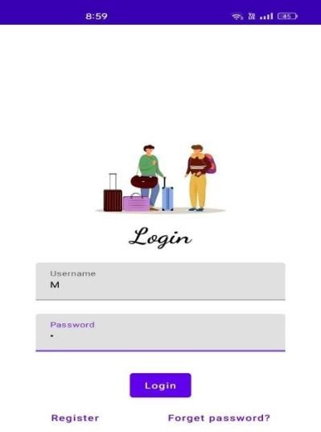 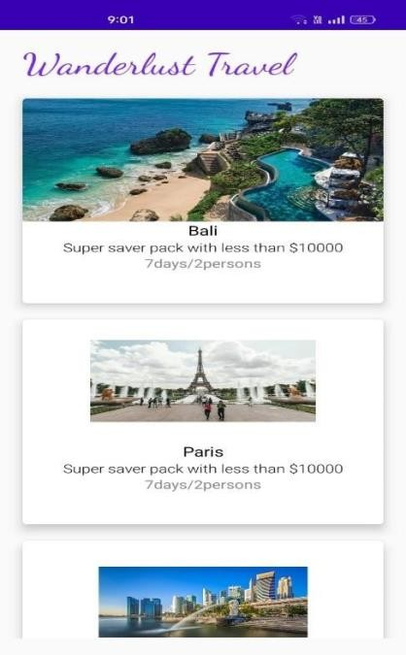

LOGIN PAGE MENU PAGE

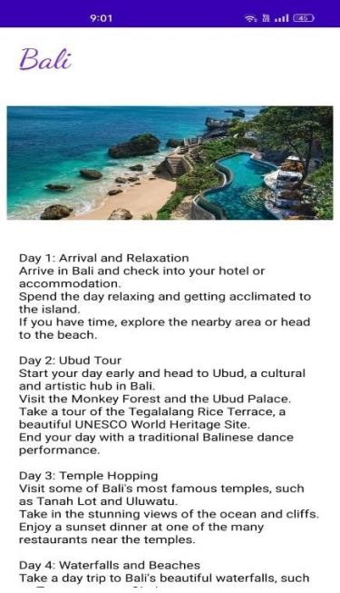

PALCES DETAILS

CONCLUSION :

In conclusion, a travel tracking app serves as a powerful tool for both travelers and adventurers, offering the convenience of organizing trips, tracking itineraries, and enhancing the overall experience. By integrating features such as real-time GPS, offline maps, budget management, and personalized recommendations, these apps empower users to navigate unfamiliar destinations with confidence and ease. Additionally, travel tracking apps contribute to improved safety, peace of mind, and efficient travel planning. As the travel landscape continues to evolve, these apps are becoming indispensable companions for anyone seeking to make the most out of their journeys. Whether for leisure, business, or exploration, a well-designed travel tracking app is a game-changer in creating seamless and unforgettable travel experiences.